
SFE316D GROUP PROJECT
Smart Waste Collection Management System (SWCMS)
2026 First Semester
 | STUDENT NUMBER | SURNAME & INITIALS | CONTACT NO. | TOTAL % | SIGNATURE
1 | 224762330 | TSONANI NE | 0692543117
2 | 224689594 | MAENETJA DM | 0661213801
3 | 224628129 | CHAUKE AF | 0633725621
4 | 224588488 | XULU TK | 0681497966
5 | 224527942 | ZONDI M | 0787572258
6 | 224473710 | MBATHA L | 0681061530

Instructions
- This is a group project.
- All the groups must have four (5) members.
- Each group approach must be unique; therefore, you are not expected to submit
the same thing.
- Handwritten work will not be accepted.
- Submit a hard copy on 16 April 2026 before 13H30 at office 20-104.
- Late submissions will not be accepted.
BUSINESS PROFILING

Background and Scenario:
Many cities face difficulties managing solid waste collection efficiently. Garbage trucks follow fixed routes and schedules regardless of actual waste levels, causing overflowing bins in some areas and wasted fuel/time in others. Citizens also lack real-time information on waste pickup schedules or overflow alerts.
The city council seeks to develop a Smart Waste Collection Management System (SWCMS) to optimize garbage collection using smart IoT-enabled bins and route optimization.
1.1 Business Need and Objectives
1.1.1 System Vision Document
Field | Details
Project | Smart Waste Collection Management System (SWCMS)
Subsystem Focus | Bin Monitoring via IoT Sensors
Problem Description
Many municipalities currently operate garbage collection using fixed schedules and predetermined routes. This approach creates several critical inefficiencies that negatively affect public health, urban aesthetics, and municipal budgets.
- Waste bins in high-traffic areas overflow before scheduled collection, causing health hazards and environmental pollution.
- Trucks are dispatched to bins that are nearly empty, wasting fuel, driver time, and operational budget.
- There is no real-time visibility into bin fill levels across the city.
- Citizens have no way to report or track overflow situations effectively.
- City supervisors cannot make data-driven decisions about resource allocation.
System Capabilities
# | Capability
1 | IoT ultrasonic sensors installed in each bin continuously measure fill levels in real time.
2 | Each smart bin transmits fill-level data wirelessly to a central monitoring server.
3 | The system generates automated alerts when a bin reaches a defined threshold (e.g., 80% full).
4 | A central dashboard displays live bin status across all city zones on a map.
5 | Historical fill-level data is logged for analysis and future route planning.
6 | The system flags malfunctioning sensors and sends maintenance notifications.
7 | Integration with the Route Optimization subsystem to trigger dynamic collection scheduling.

Business Benefits
Benefit | Description
Cost Reduction | Eliminates unnecessary truck dispatches to low-fill bins, reducing fuel and labour costs.
Improved Public Health | Prevents bin overflow, reducing exposure to disease-causing waste.
Operational Efficiency | Collection teams respond only when and where needed.
Data-Driven Decisions | Management gains insight into waste generation patterns per zone.
Environmental Impact | Reduced vehicle emissions from optimized collection runs.
Scalability | System can expand to monitor more bins as the city grows.

1.2 Business Analysis and Modeling
1.2.1 System Subsystems / Components
The SWCMS is divided into the following five (5) subsystems:
1. Bin Monitoring Subsystem (Selected Focus)
Uses IoT ultrasonic sensors embedded in smart bins to continuously measure and transmit real-time fill levels to the central server. Triggers alerts when thresholds are exceeded.
2. Route Optimization Subsystem
Receives fill-level alerts from the Bin Monitoring subsystem and dynamically generates the most efficient collection routes for garbage trucks, replacing fixed schedules.
3. Fleet & Driver Management Subsystem
Manages garbage truck assignments, driver schedules, GPS tracking of vehicles, and delivery of optimized routes to drivers via mobile devices.
4. Citizen Notification Portal
A web/mobile interface allowing residents to view bin collection schedules, report overflowing bins, and receive alerts about delays or service disruptions in their area.
5. Reporting & Analytics Subsystem
Aggregates data from all subsystems to generate operational reports, waste trend analyses, and performance dashboards for city management and decision-makers.
1.2.2 Workflow – Bin Monitoring Subsystem
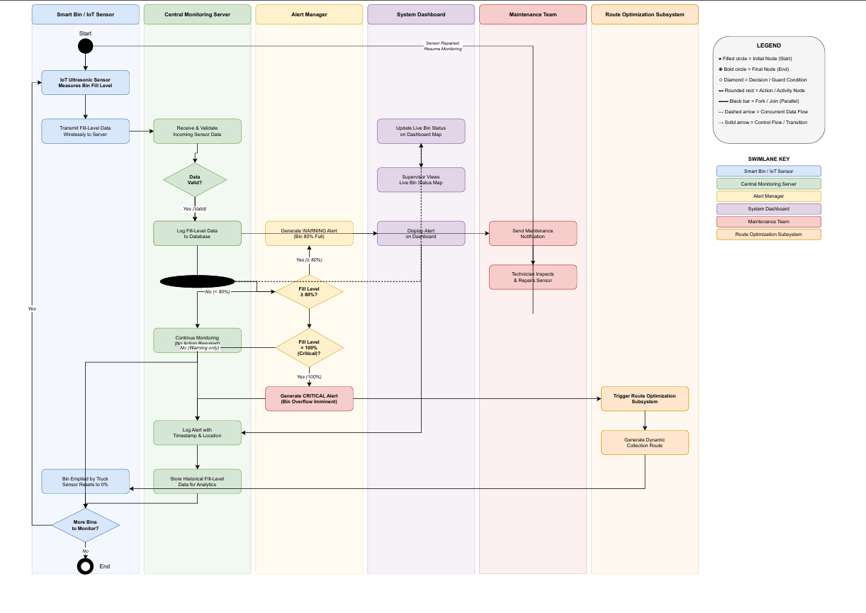
2. Requirements Modelling
2.1 Use Case Modelling
2.1.1 User Stories for the users of our Selected Subsystem
a) IoT Sensor as an IoT Sensor, I want to continuously measure the bin fill level and transmit the data wirelessly to the central server so that the system always has up-to-date bin status information.
b) City Supervisor, I want to view a live map dashboard showing the fill level of all bins across the city so that I can monitor waste levels and make informed dispatch decisions.
c) City Supervisor, I want to receive automated alerts when a bin reaches 80% or 100% capacity so that I can act before overflow occurs.
d) Maintenance Technician, as a Maintenance Technician, I want to receive a notification when a bin sensor is flagged as malfunctioning so that I can inspect and repair it before it causes data gaps.
e) Citizen As a Citizen, I want to report an overflowing bin through a portal so that the city can respond quickly to public health hazards in my area.
f) City Planner / Management as a City Planner, I want to access historical fill-level data and waste trend reports so that I can make data-driven decisions about bin placement and collection frequency.

2.1.2 Even Decomposition

# | Event Type | Event | Use Case Identified
1 | External | Sensor reads bin fill level | Measure Bin Fill Level
2 | External | Sensor transmits data to server | Transmit Fill-Level Data to Server
3 | External | Server receives sensor data | Validate Sensor Data
4 | Temporal | System checks data at each cycle | Log Fill-Level Data to Database
5 | State change | Fill level reaches 80% | Generate Warning Alert
6 | State change | Fill level reaches 100% | Generate Critical Alert
7 | Temporal | After every data log | Update Live Dashboard Map
8 | External | Supervisor opens dashboard | View Bin Status on Dashboard
9 | State change | Sensor returns invalid/no data | Flag Sensor Malfunction
10 | External | System detects malfunction | Send Maintenance Notification
11 | External | Critical alert is triggered | Trigger Route Optimization

2.1.3 CRUD Technique
Entity | Create | Read | Update | Delete
Bin | Register New Bin | View Bin Details / Location | Update Bin Status (fill %, GPS) | Decommission Bin
Sensor | Install / Register Sensor | View Sensor Health Status | Update Sensor Calibration | Remove Faulty Sensor
Alert | Generate Warning / Critical Alert | View Active Alerts | Acknowledge / Resolve Alert | Purge Resolved Alerts
Fill-Level Record | Log Fill-Level Data | View Historical Fill Data | Correct Erroneous Reading | Archive Old Records
Maintenance Report | Create Maintenance Request | View Maintenance History | Update Repair Status | Delete Closed Report

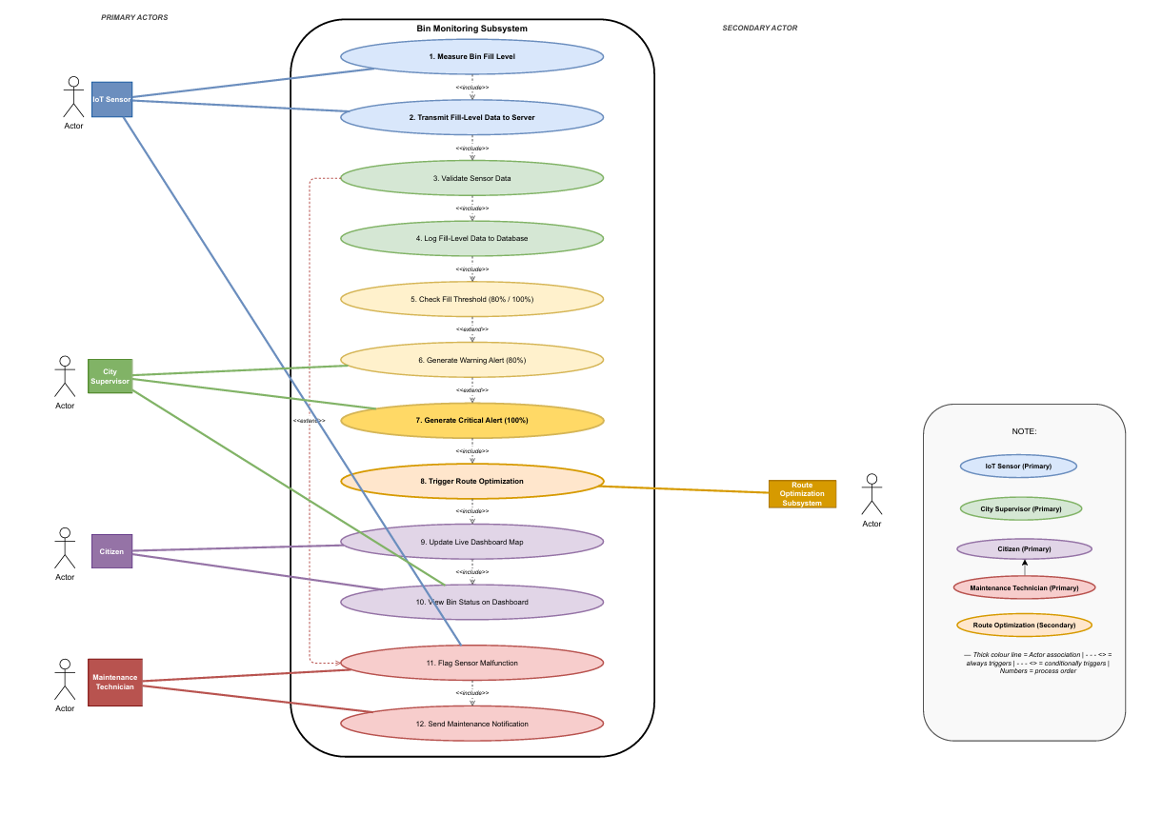
2.1.4 USE CASE DIAGRAM

3. DETAILED REQUIREMENTS MODELLING
3.1 Fully Developed Use Case Descriptions
Use Case 5: Check Fill Threshold
Field | Details
Use Case Name | Check Fill Threshold
Use Case ID | UC5
Actor(s) | IoT Sensor (primary), City Supervisor (primary)
Trigger | Sensor transmits a fill-level reading to the central server
Preconditions | Sensor is active; server is online; fill-level data has been received and validated
Main Flow | 1. Sensor reads and transmits fill level to server. 2. Server logs the reading. 3. Alert Manager compares fill level to thresholds. 4. If < 80%, no action — monitoring continues. 5. If ≥ 80%, Warning Alert is generated. 6. If = 100%, Critical Alert is generated. 7. Alert is logged with timestamp and bin ID. 8. Dashboard is updated and supervisor is notified. 9. If critical, Route Optimization is triggered.
Postconditions | Alert is logged; supervisor is notified; route optimization triggered if critical
Alternative Flow | If fill level drops below 80% before collection, warning alert is cleared and monitoring resumes

Use Case 11: Flag Sensor Malfunction
Field | Details
Use Case Name | Flag Sensor Malfunction
Use Case ID | UC11
Actor(s) | IoT Sensor (primary), Maintenance Technician (primary), System Dashboard
Trigger | Server detects invalid data or no signal from a sensor
Preconditions | Sensor has been transmitting; server is online and monitoring transmissions
Main Flow | 1. Sensor transmits data to server. 2. Server checks data integrity. 3. If data is invalid or signal is lost after retries, Alert Manager flags sensor as malfunctioning. 4. Malfunction event is logged. 5. Maintenance ticket is created. 6. Dashboard marks sensor offline. 7. Maintenance notification sent to technician. 8. Technician inspects and repairs or replaces sensor. 9. Malfunction flag is cleared; sensor marked back online.
Postconditions | Sensor is repaired/replaced; malfunction flag cleared; dashboard updated; monitoring resumes
Alternative Flow | If data error resolves on retry (within 3 attempts), sensor returns to Active state without flagging

3.2 Activity Diagrams
Use Case 5: Check Fill Threshold
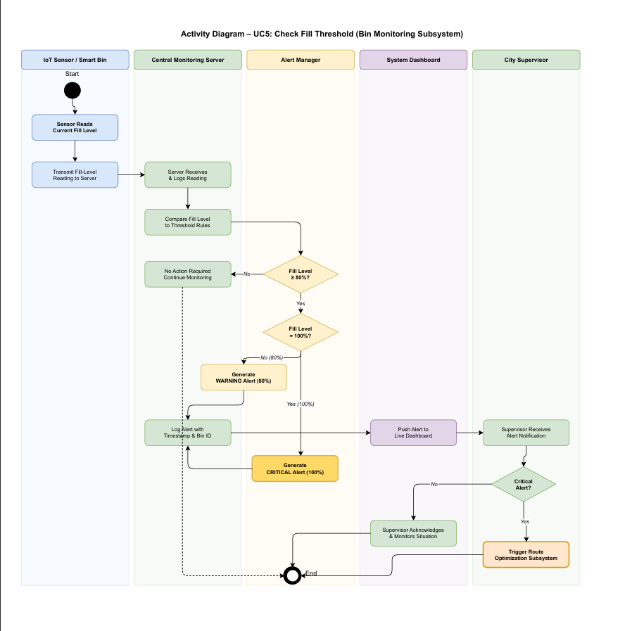
Use Case 11: Flag Sensor Malfunction
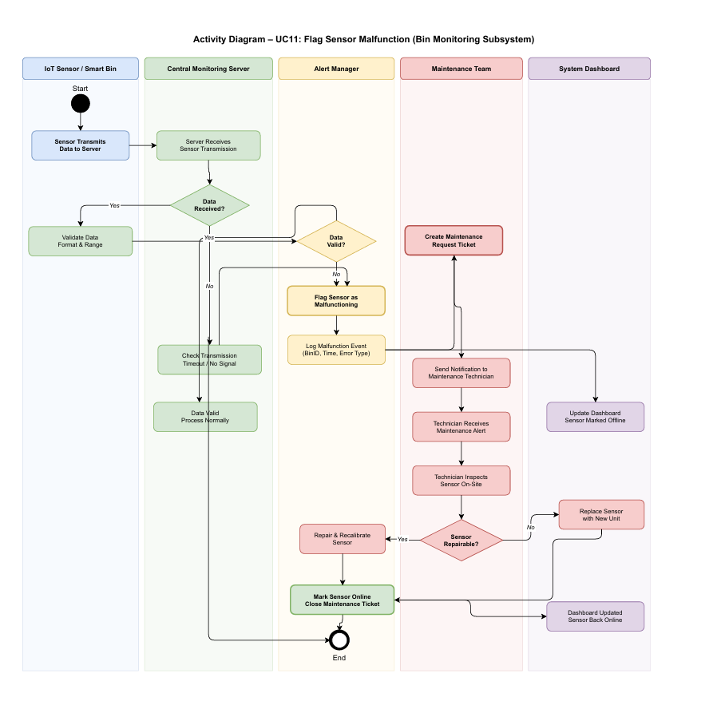

3.3 System Sequence Diagram
Use Case 5: Check Fill Threshold
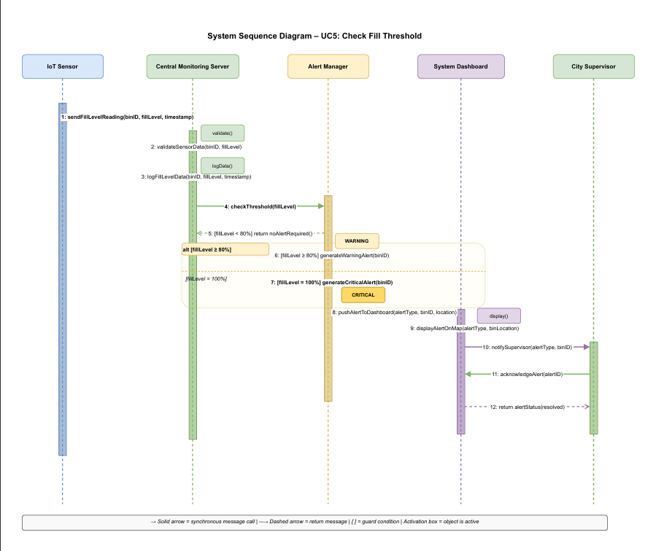
Use Case 11: Flag Sensor Malfunction
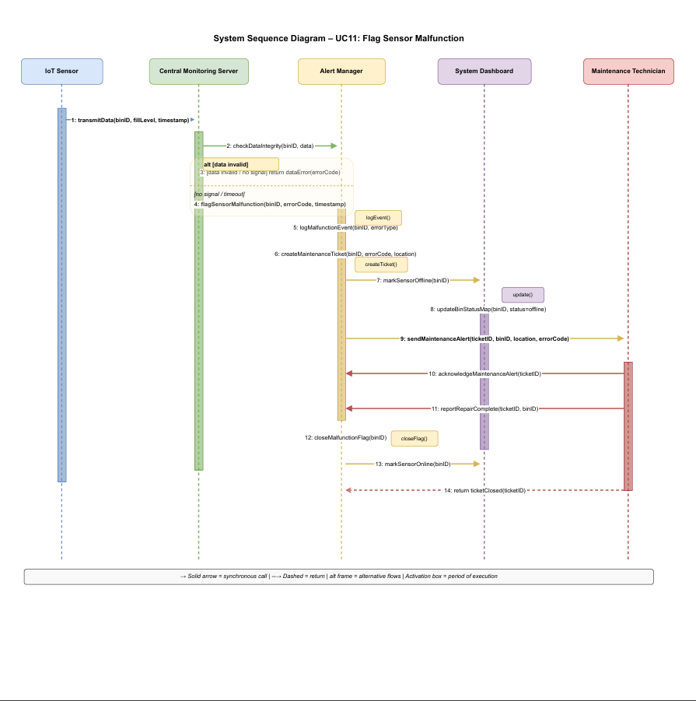

3.4 State Machine Diagram
Use Case 5: Check Fill Threshold
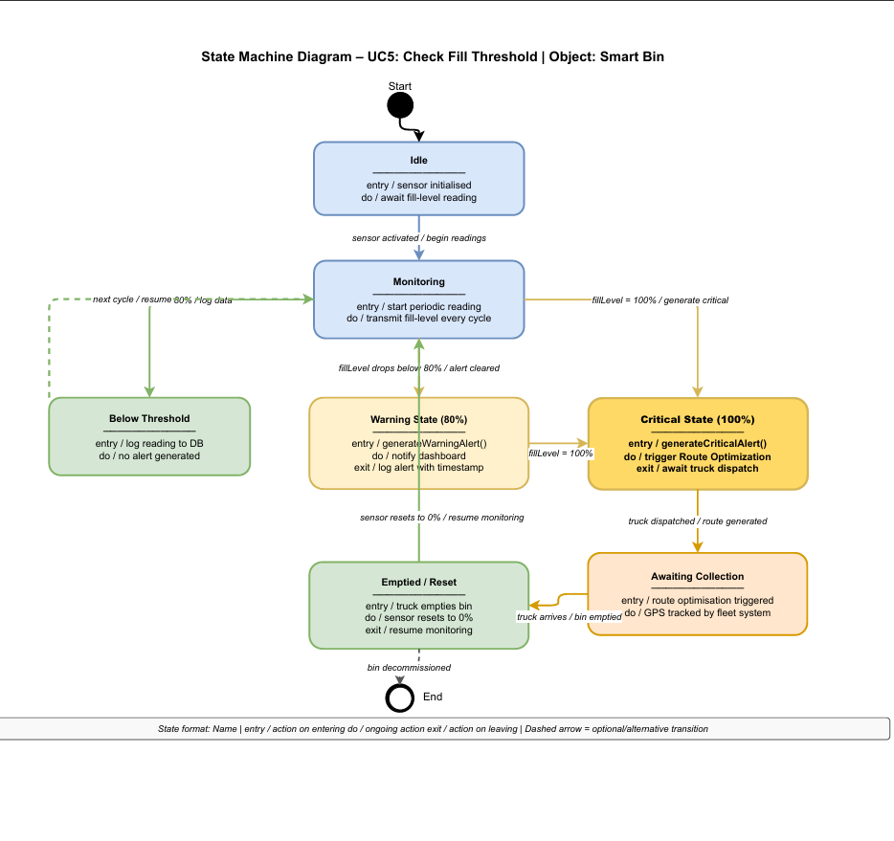
Use Case 11: Flag Sensor Malfunction
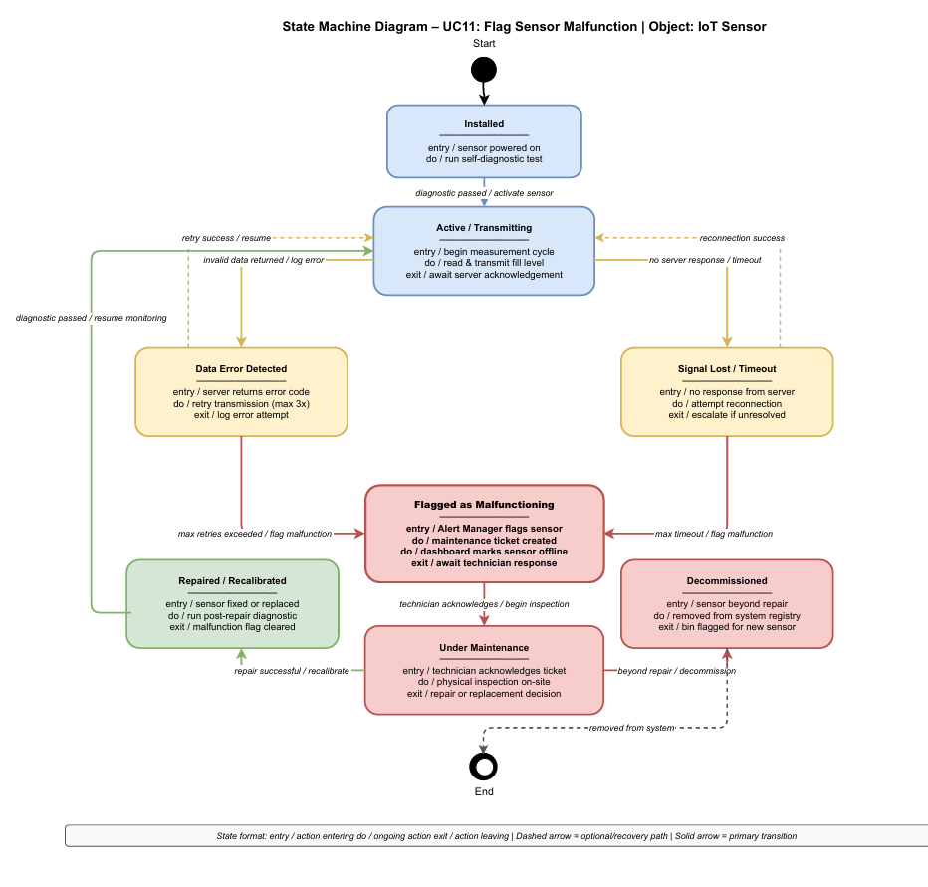

4. SYSTEM DESIGN
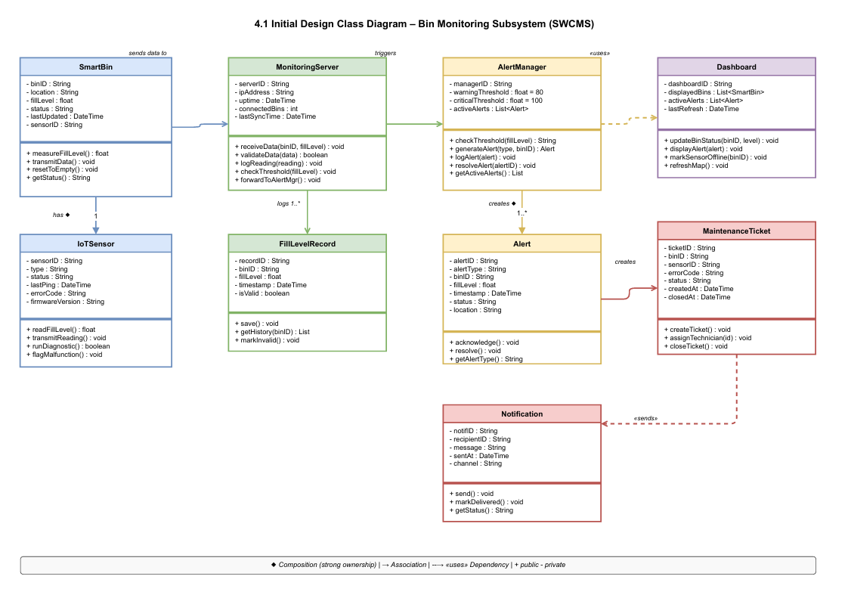
4.1 Initial Design Class Diagram
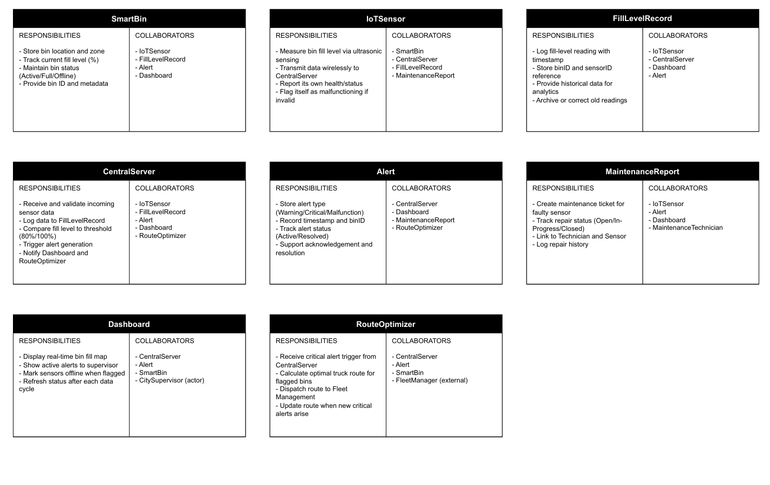
4.2 CRC CARDS
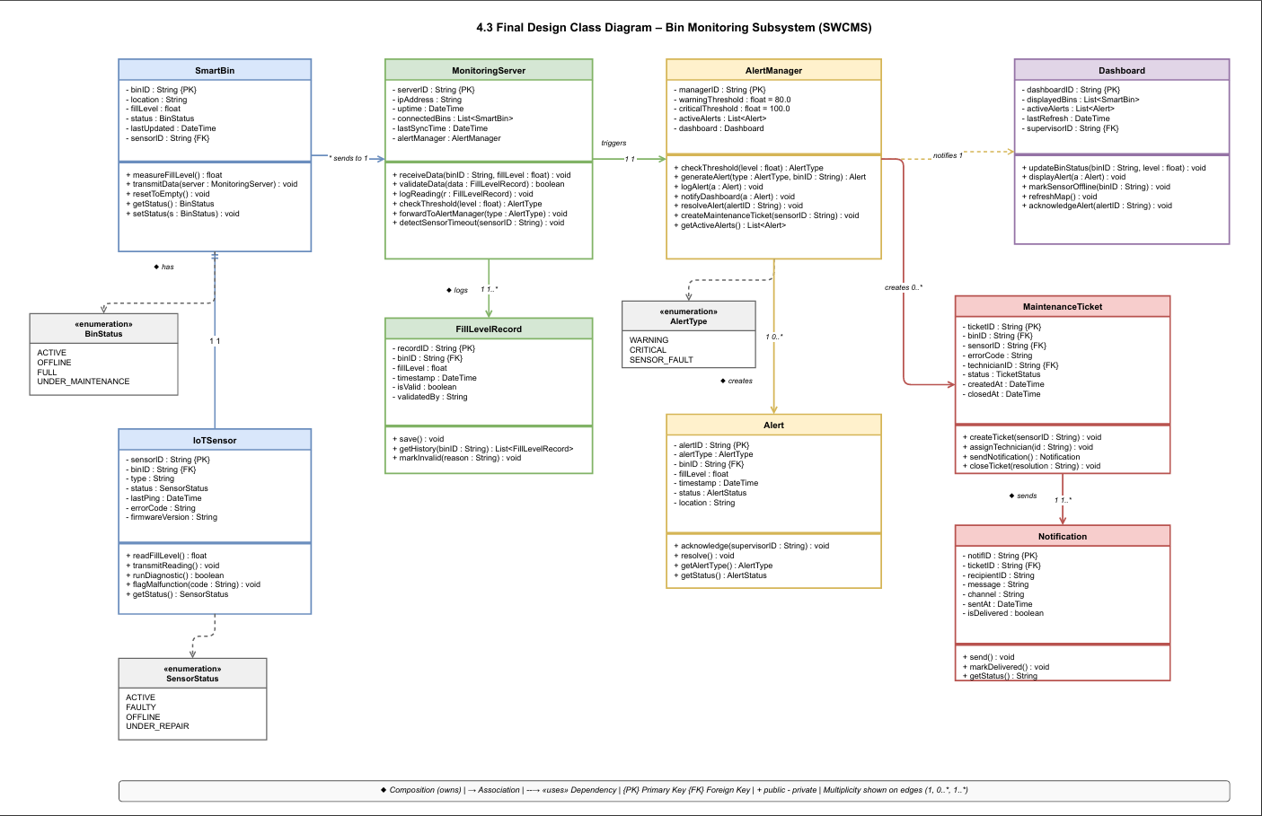
4.3 FINAL CLASS DIAGRAM
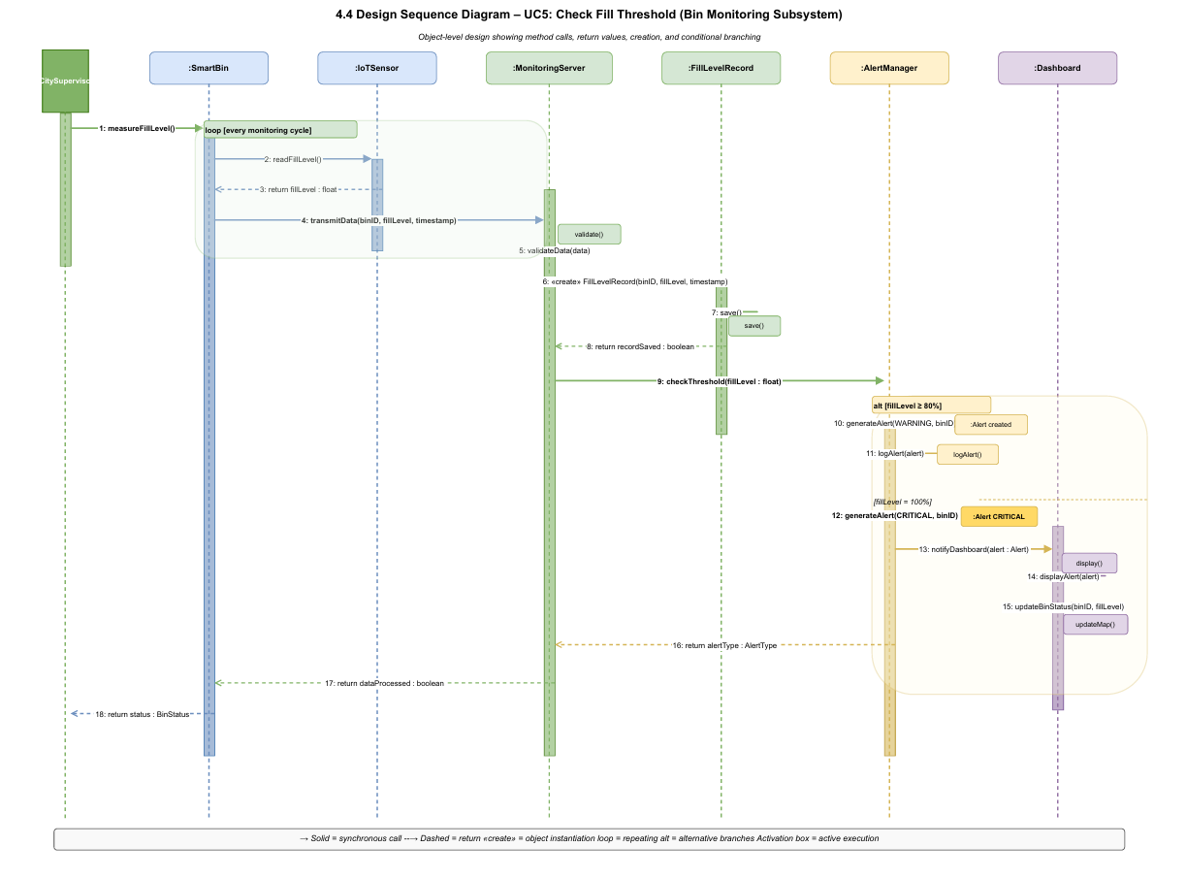
4.4 SYSTEN SEQUENCE DIAGRAM

